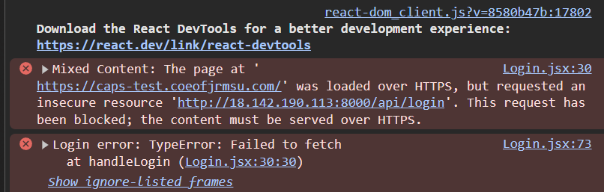
HOW TO FIX THIS BUG:
1. Install NNGINX on Server:
- Navigate to the cloned files in server
- Type: sudo apt update
- Type: Sudo apt install nginx -y
2. Create config for domain:
Type: sudo nano/etc/nginx/sites-available/caps-test
Paste this code in config:
server {
listen 80;
server_name caps-test.coeofjrmsu.com;

location / {
proxy_pass http://localhost:5173; # Frontend (Vite)
proxy_http_version 1.1;
proxy_set_header Host $host;
proxy_set_header Upgrade $http_upgrade;
proxy_set_header Connection 'upgrade';
proxy_set_header X-Forwarded-For $proxy_add_x_forwarded_for;
}

location /api/ {
proxy_pass http://localhost:8000; # Backend (Laravel)
proxy_set_header Host $host;
proxy_set_header X-Real-IP $remote_addr;
proxy_set_header X-Forwarded-For $proxy_add_x_forwarded_for;
proxy_set_header X-Forwarded-Proto $scheme;
}
}
3. Save it By Pressing CTRL + O, PRESS ENTER, CTRL +X
4. Enable the configuration by typing:
sudo ln -s /etc/nginx/sites-available/caps-test /etc/nginx/sites-enabled/
sudo nginx -t
sudo systemctl restart nginx
5. Use HTTPS and install certbot by typing:
sudo apt install certbot python3-certbot-nginx -y
sudo certbot --nginx -d caps-test.coeofjrmsu.com
6. navigate to the caps-frontend file and type: npm run build
7. Remove the code in .env file in paste this:
VITE_API_BASE_URL=https://caps-test.coeofjrmsu.com/api
8. The bug should be gone and you can now login

